**Exp 07: Create a Virtual Machine with 1 CPU, 2GB RAM and 15GB storage disk using**

**a Type 2 Virtualization Software, using virtual box.**

**Aim**

To install and Create a Virtual Machine with 1 CPU, 2GB RAM and 15GB storage disk using

a Type 2 Virtualization Software, using virtual box.

**Procedure**

1. **Open VirtualBox** → Launch the VirtualBox application installed on your system.
2. **Create New VM** → Click on “New”, enter a name for the VM, and select the desired operating system type and version.
3. **Allocate Memory** → Assign **2 GB (2048 MB)** of RAM to the VM.
4. **Configure CPU** → Set the **Processor count to 1 CPU** under “System → Processor” tab.
5. **Create Virtual Hard Disk** → Choose “Create a virtual hard disk now”, select **VDI**, and allocate **15 GB** of storage.
6. **Attach OS Installation Media** → In the “Storage” settings, mount an ISO image of the operating system you want to install.
7. **Start VM** → Click “Start” to boot the virtual machine and begin OS installation.

**Output**

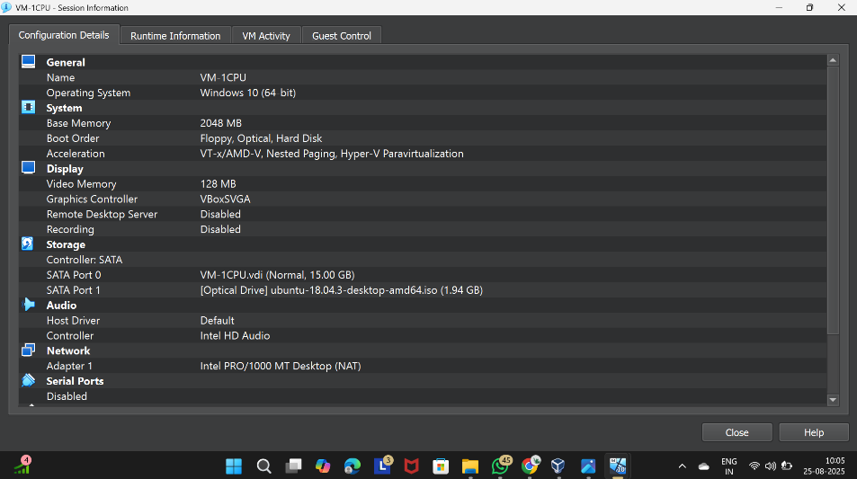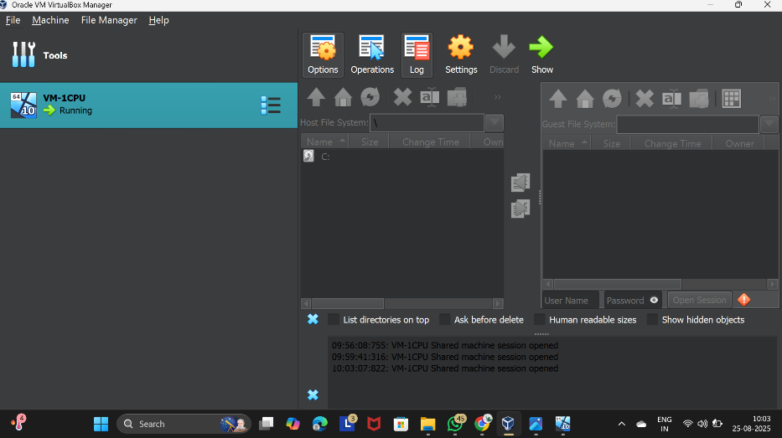

Figure 1 Virtual Machine with 1 CPU, 2 GB RAM, and 15 GB storage

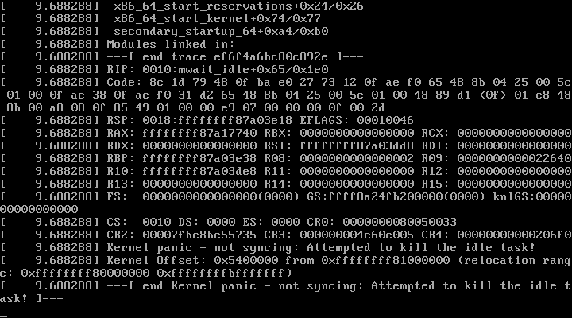

**Result**

A Type-2 hypervisor (VirtualBox) was successfully installed on the host machine. A Virtual Machine was created with the configuration **1 CPU, 2 GB RAM, 15 GB storage**, and a guest operating system (Ubuntu/Windows) was installed and executed successfully.